

**AMERICAN INTERNATIONAL UNIVERSITY–BANGLADESH (AIUB)**

**FACULTY OF SCIENCE & TECHNOLOGY**

**DEPARTMENT OF COMPUTER SCIENCE**

**SOFTWARE QUALITY AND TESTING**

**Spring 2024-2025**

**Section: [B]**

**Assignment 1**

# 

**Supervised By:**

**ABHIJIT BHOWMIK**

**Submitted By:**

|  |  |
| --- | --- |
| **Name** | **ID** |
| 1. PROTTOY SAHA | 21-45640-3 |
| 2. FARDIN ABU UBAID | 21-44864-2 |
| 3. MUHTASIB IBTIDA KOUSIK | 21-44863-2 |
| 4. MD. REZUAN HUSSAIN | 21-45389-3 |

Submission date: May-18, 2025

**Installation of Selenium**

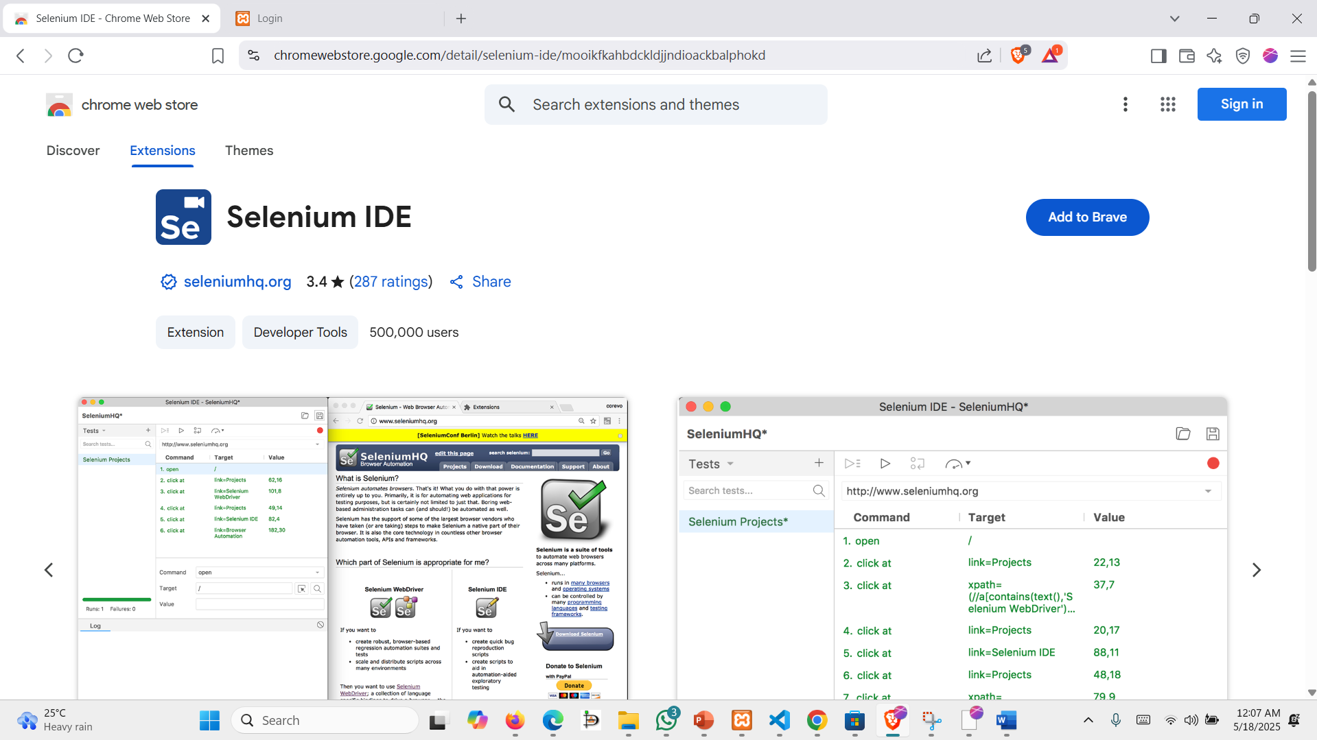

**Step1:** Firstly, we went into our browser then in the search bar we typed selenium IDE. After going into the proper website, we clicked on the add to browser button to install the Extension of the Selenium IDE for our browser.

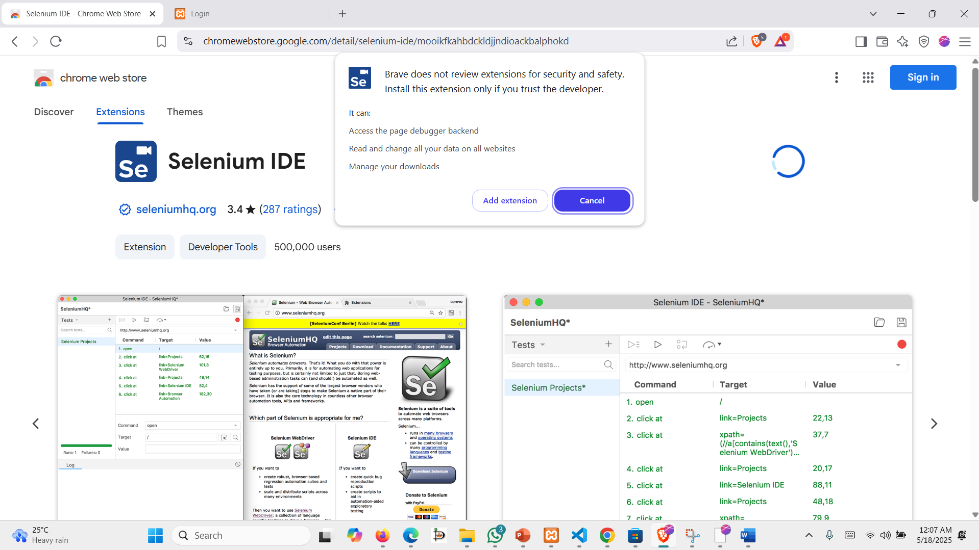

**Step 2:** After clicking on add to brave button it shows a warning. After that we clicked on the add extension button to install the extension into our browser

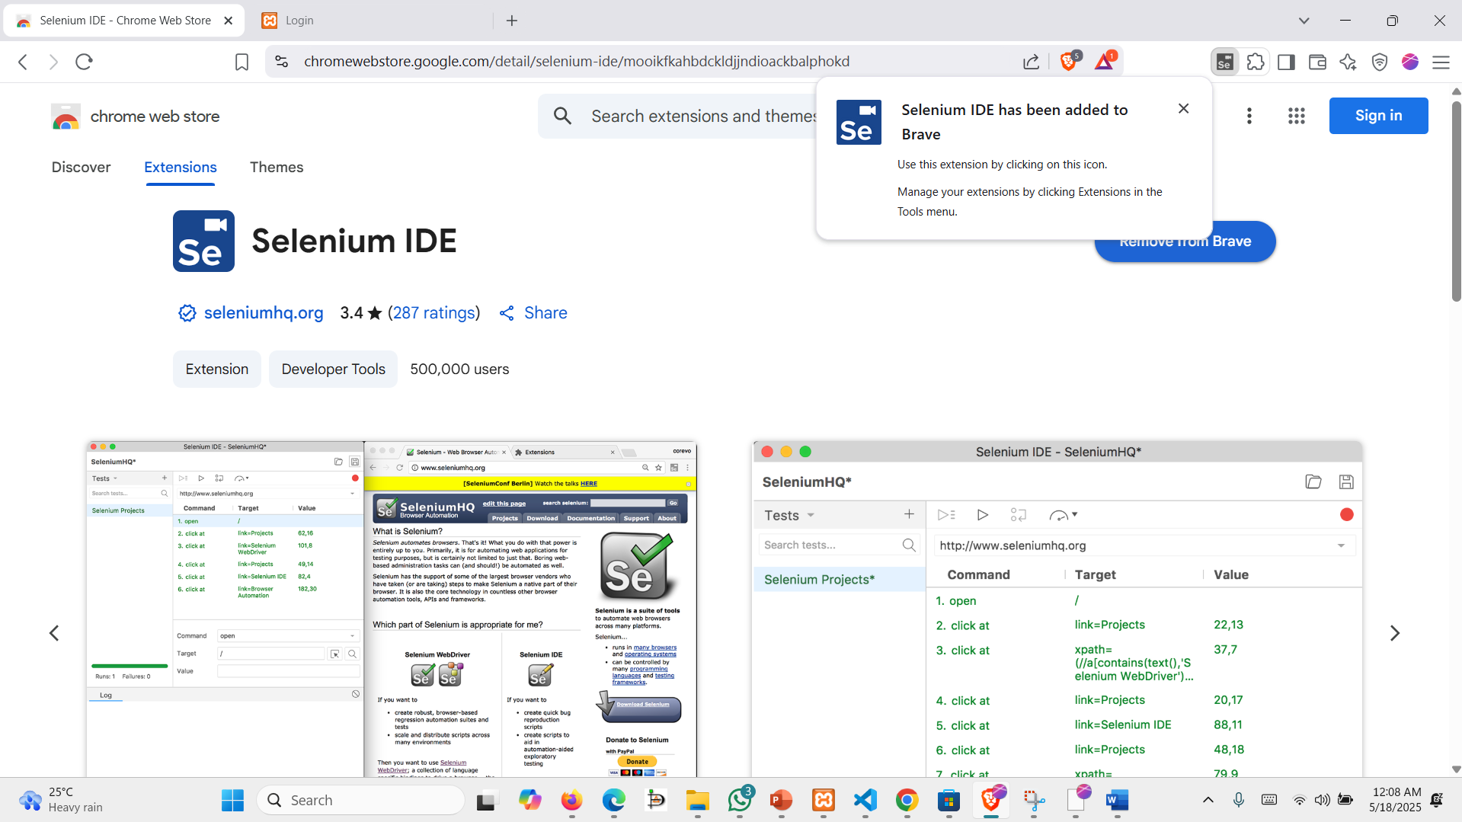

**Step 3:** The output shows that the selenium extension has been added to our browser.

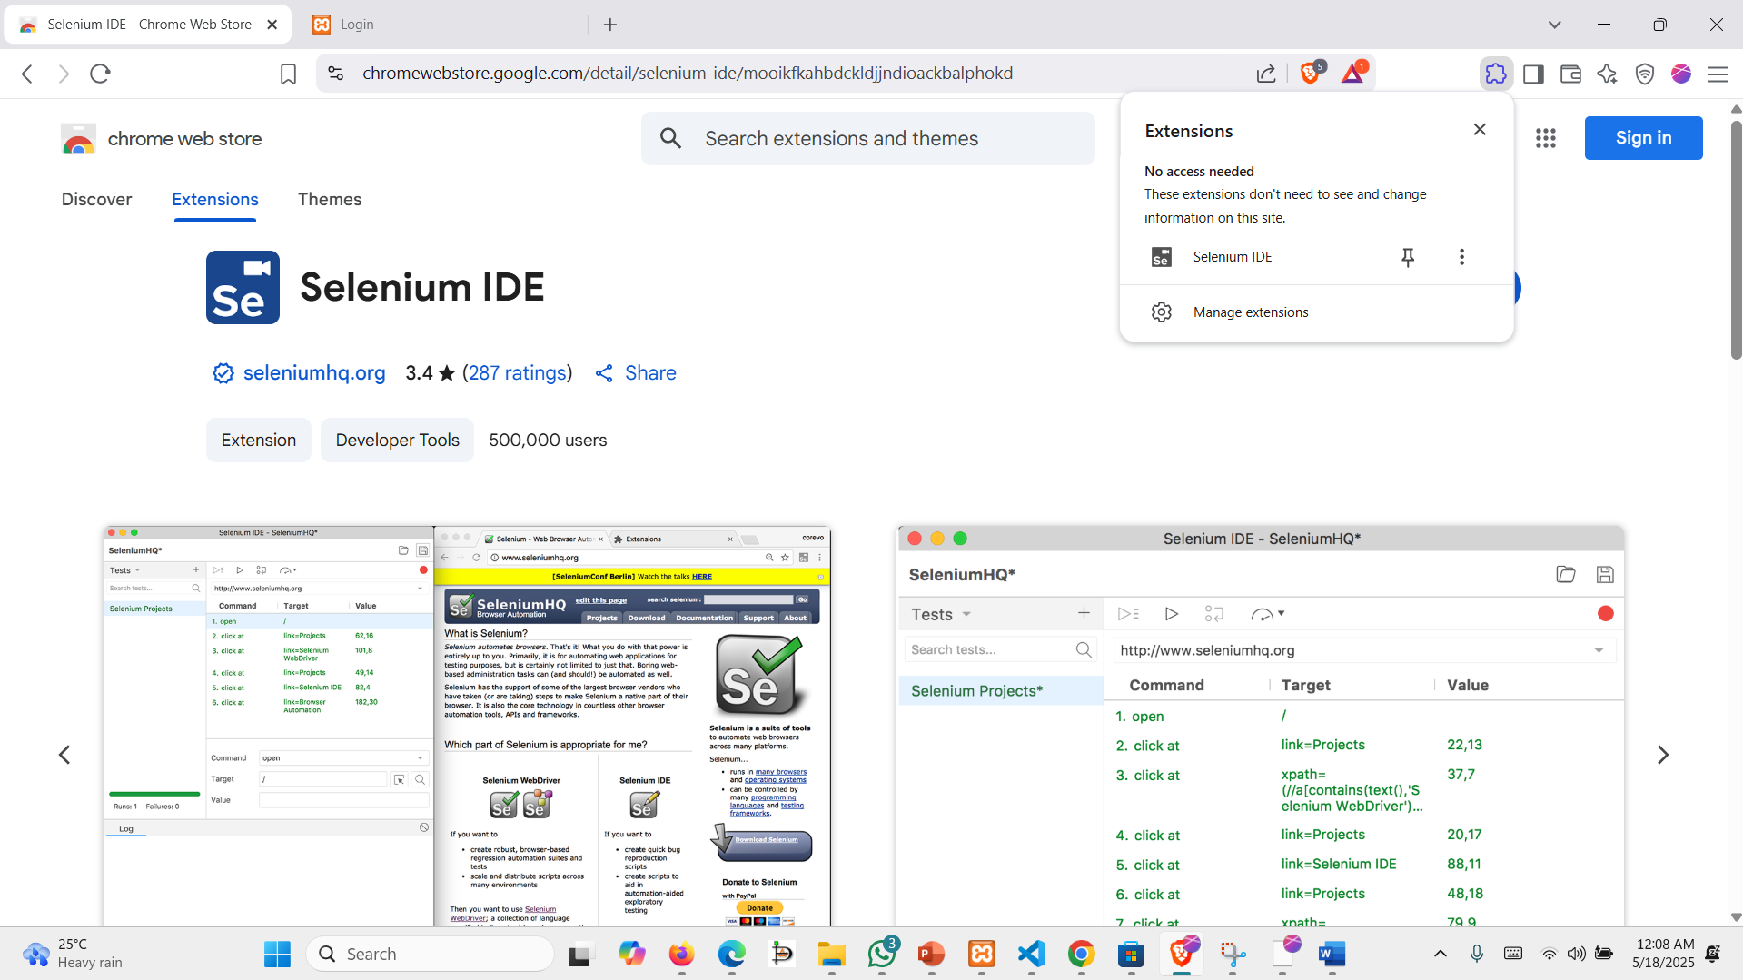

**Step 4:** To verify that selenium has been installed properly in our browser here after clicking into our browser’s extension option the selenium IDE extension is properly installed into our web browser as a result the icon of the selenium IDE is showing in our extension.

**Creating a project on selenium:**

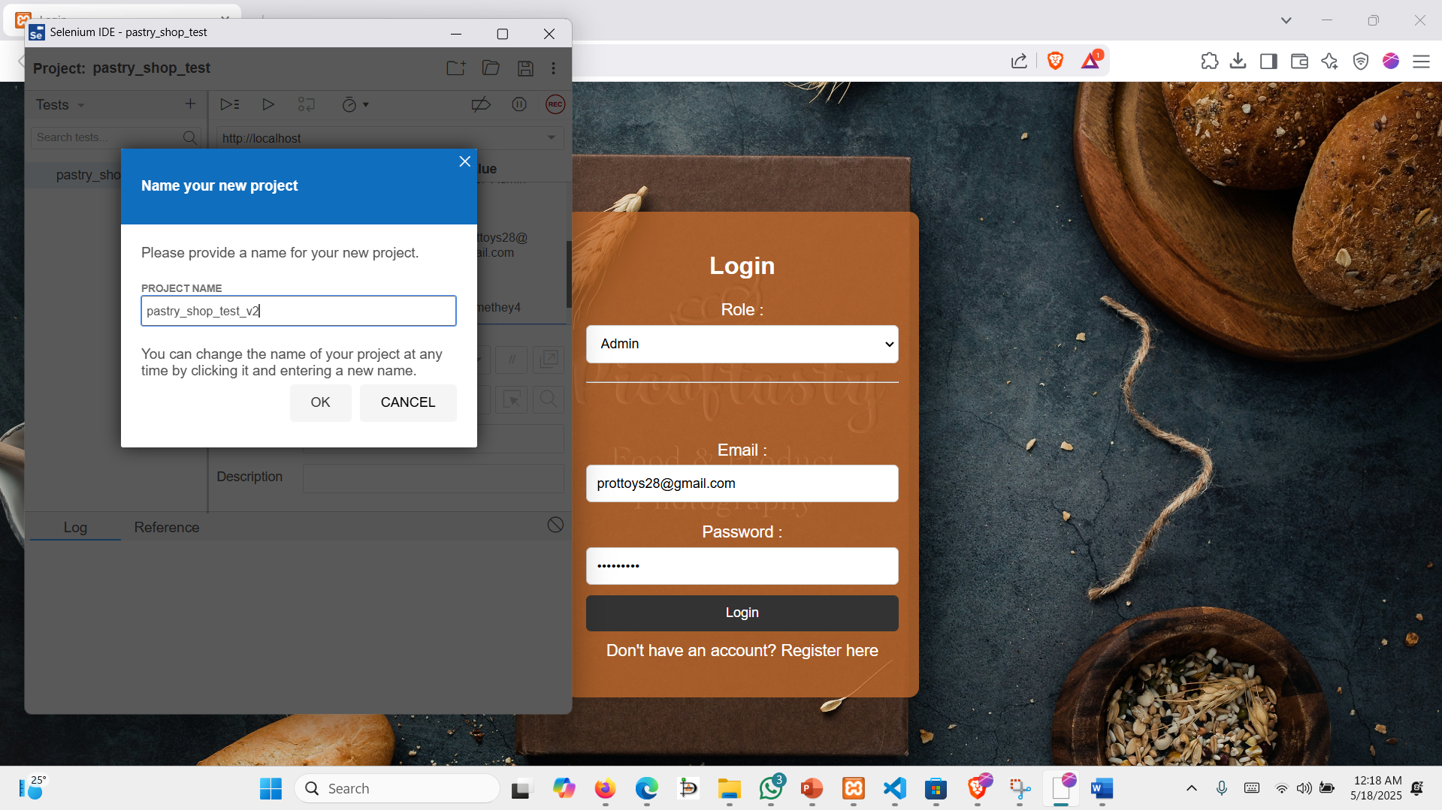

**Step 1:** Here after clicking on the extension of the selenium from our browser a prompt showing that to choose between various options such as creating a new project, opening an existing project etc. From here we clicked on to create a new project and then a text-box appeared asking to provide an input for project name and here we named our project as pastry_shop_test_v2.

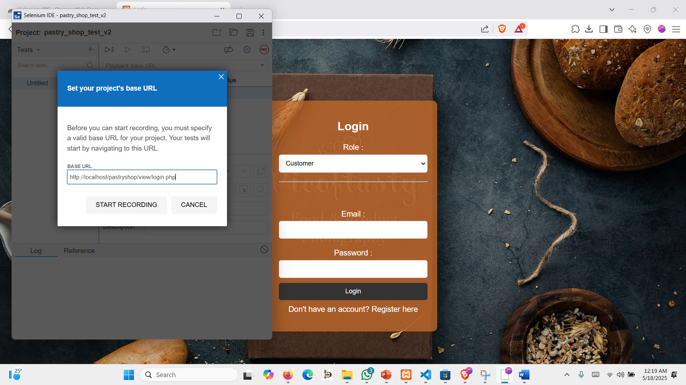

**Step 2:** after naming our project the selenium is asked for to provide the URL of the webpage which we want to test through the software. Here we put the URL of our own created project based on HTML, CSS, JS, AJAX pastry shop management system. Then we clicked on the start recording button.

**Test 1: Log-in with valid user email address and password**

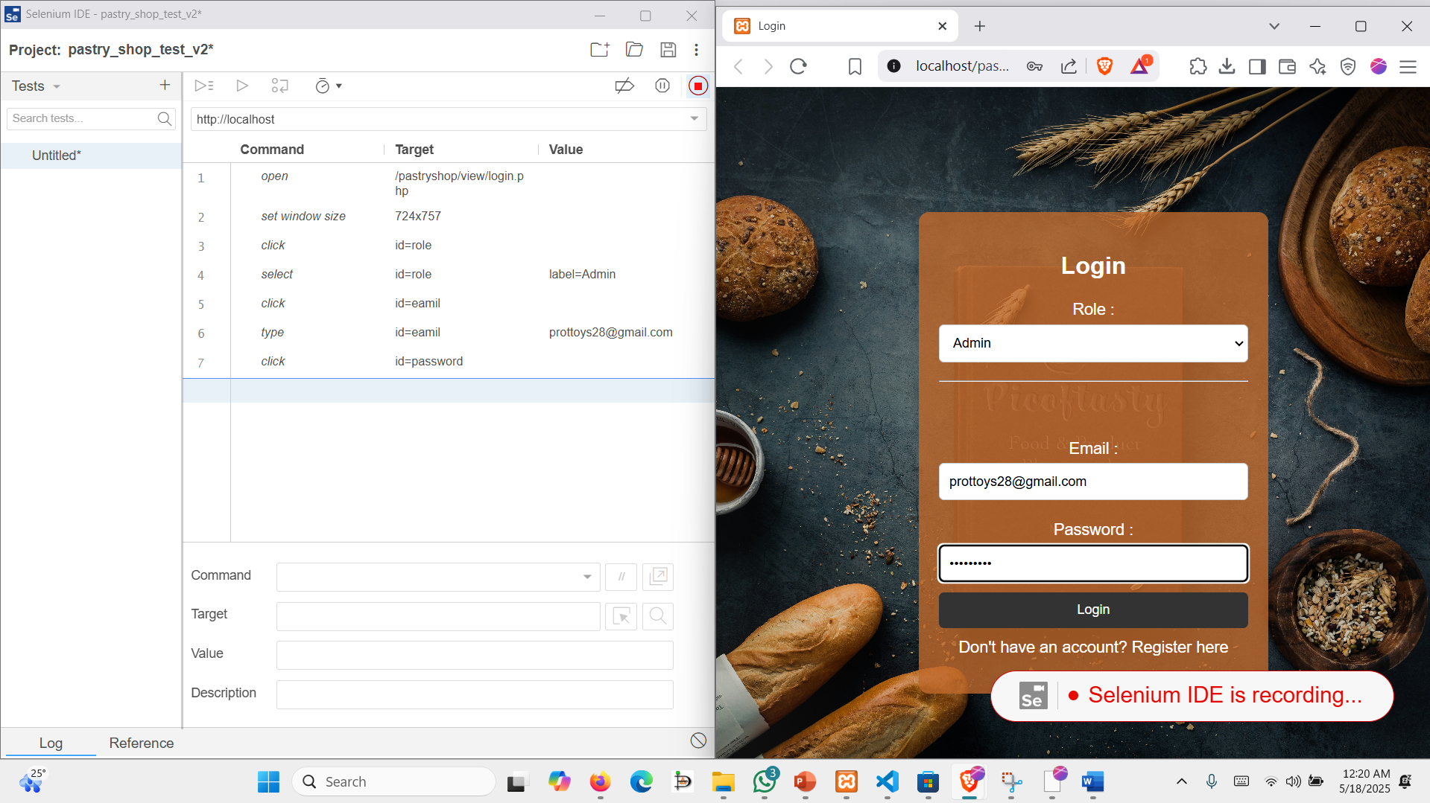

**Step 1:** After clicking on start recording in the previous step it can be seen that the selenium has been started recording of the test it can be verified by noticing on the top right corner a red colored button is showing that the test has been recording also in the web page there is a text showing that selenium IDE is recording in the right side of the screen. So, here for every click Command, Target and value is recorded automatically in the selenium. Where command means about the Selenium what action to perform. Target means which element on the page the command should interact with, and value means if extra data needed by some commands, especially textbox and select option.

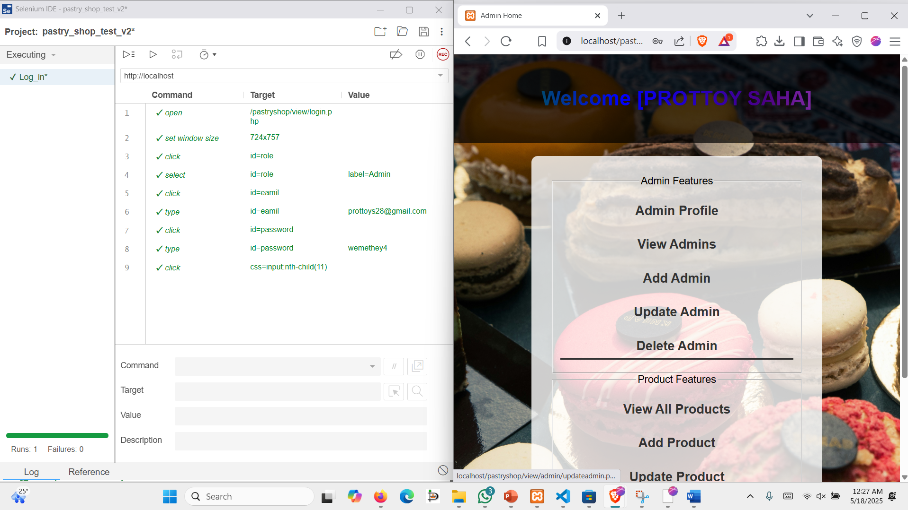

**Step 2:** After the recording has successfully been recorded now it can be seen that there are 2 options in the lower top side of the left sided screen where one option is for running all tests and another option is for running current tests. Here, running current test case runs only the selected test step-by-step automatically. Run all test cases runs all test cases listed in our suite in a sequence. So, for our testing we selected the run current test case which shows us:

The automated test case simulates a user logging in as an Admin and there were these following steps performed:

* The browser navigated to the login page (/pastryshop/view/login.php).
* The browser window was resized to simulate a realistic view.
* The user role dropdown was selected and set to "Admin".
* The email field (id=eamil) was clicked and filled with a valid email address: prottoys28@gmail.com.
* The password field was selected and filled with the password wemethey4.
* The login button (identified via CSS selector) was clicked to submit the form.

Each step executed successfully, confirming that the login page's inputs and form submission are working correctly under normal conditions.

**Test 2: Log-in with unregistered user-email and password**

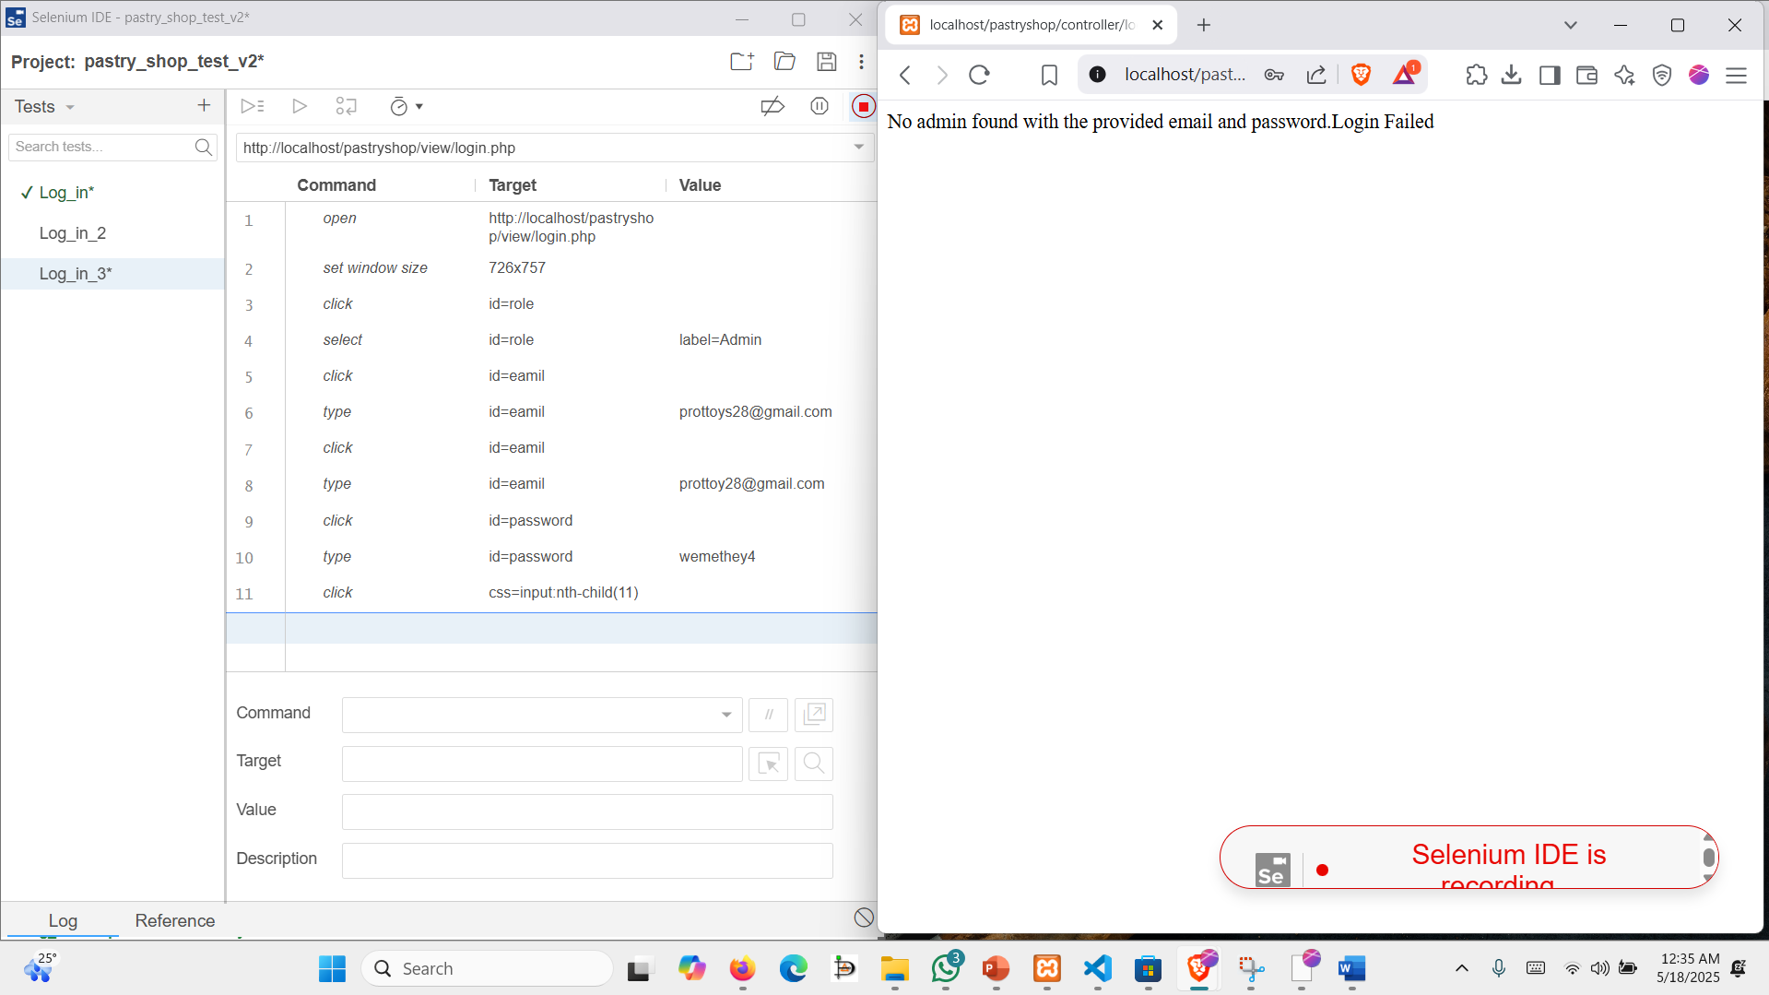

**Step 1:** We manually created another test by clicking on the top upper + sign where we named the untitled test as Log_in_2. Then by following the same steps we start recording our test but here what we did is give input of some unregistered mail and password which means these mail and password are not registered in our project.

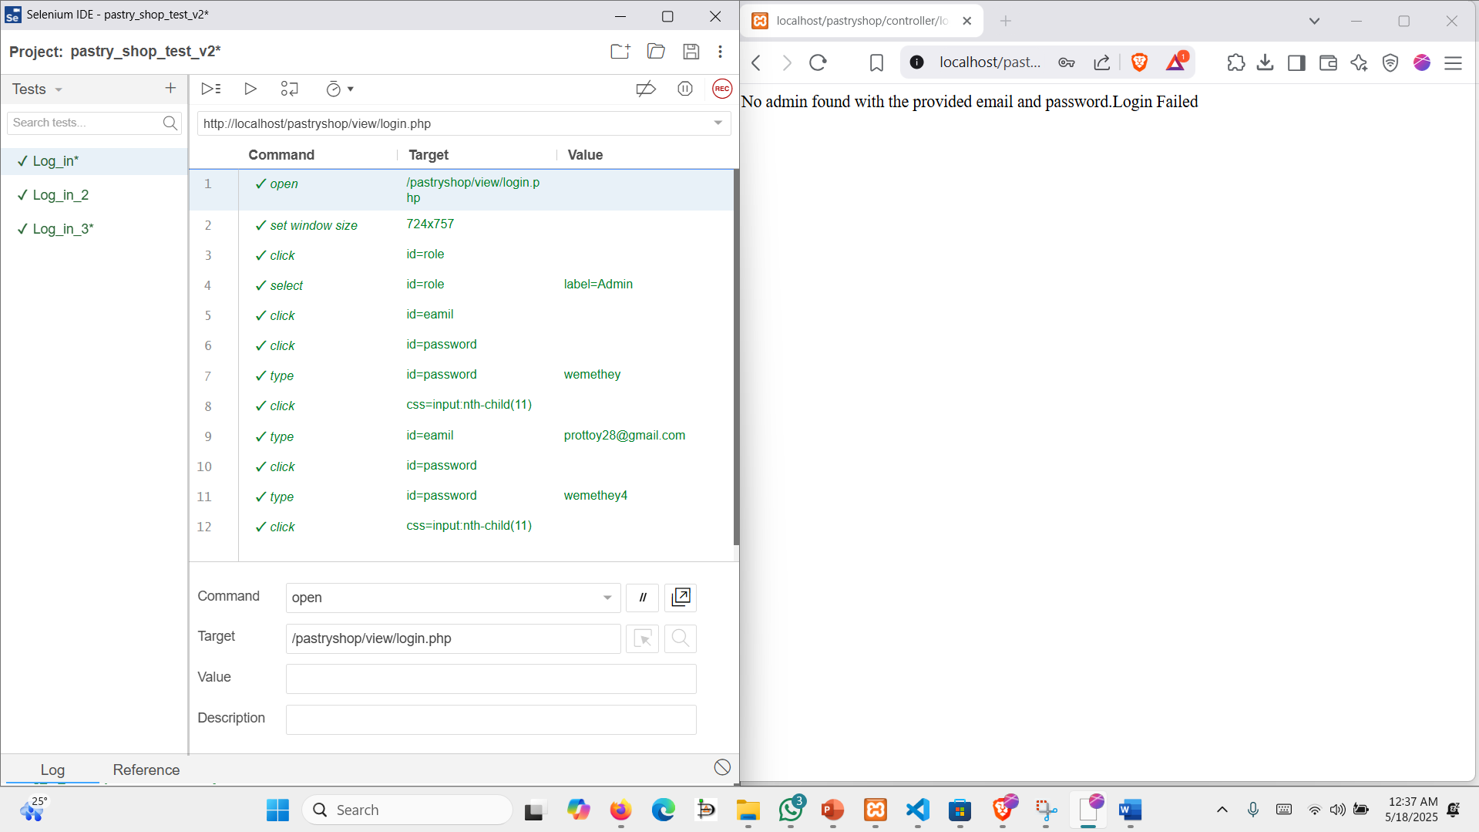

**Step 2:** This automated test case was created and executed using Selenium IDE to verify the login process on the system.

* The test began by opening the login page (/pastryshop/view/login.php) and adjusting the browser window size.
* The user role dropdown (id=role) was selected and set to Admin.
* The test initially attempted to enter the password before the email, simulating a realistic user error.
* It then corrected the input sequence by entering the correct email (prottoy28@gmail.com) and updated password (wemethey4).
* The login button was clicked twice: once with incorrect input order and again after correcting it.
* The final attempt succeeded, and the login process completed successfully.

This test confirms that the login form correctly handles user input and functions as expected when valid credentials are provided.

**Test 3: Testing the Registration functionalities of the website**

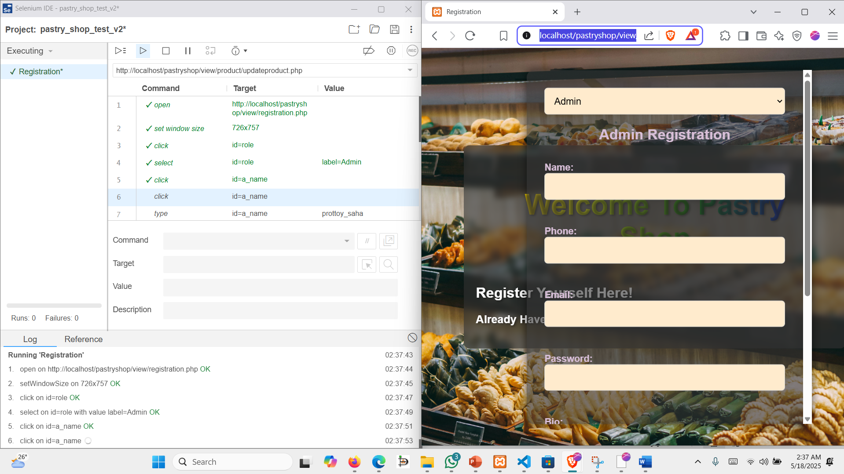

**Step 1:** We manually created another test by clicking on the top upper + sign where we named the untitled test as Registration. Then by following the same steps we start recording our test.

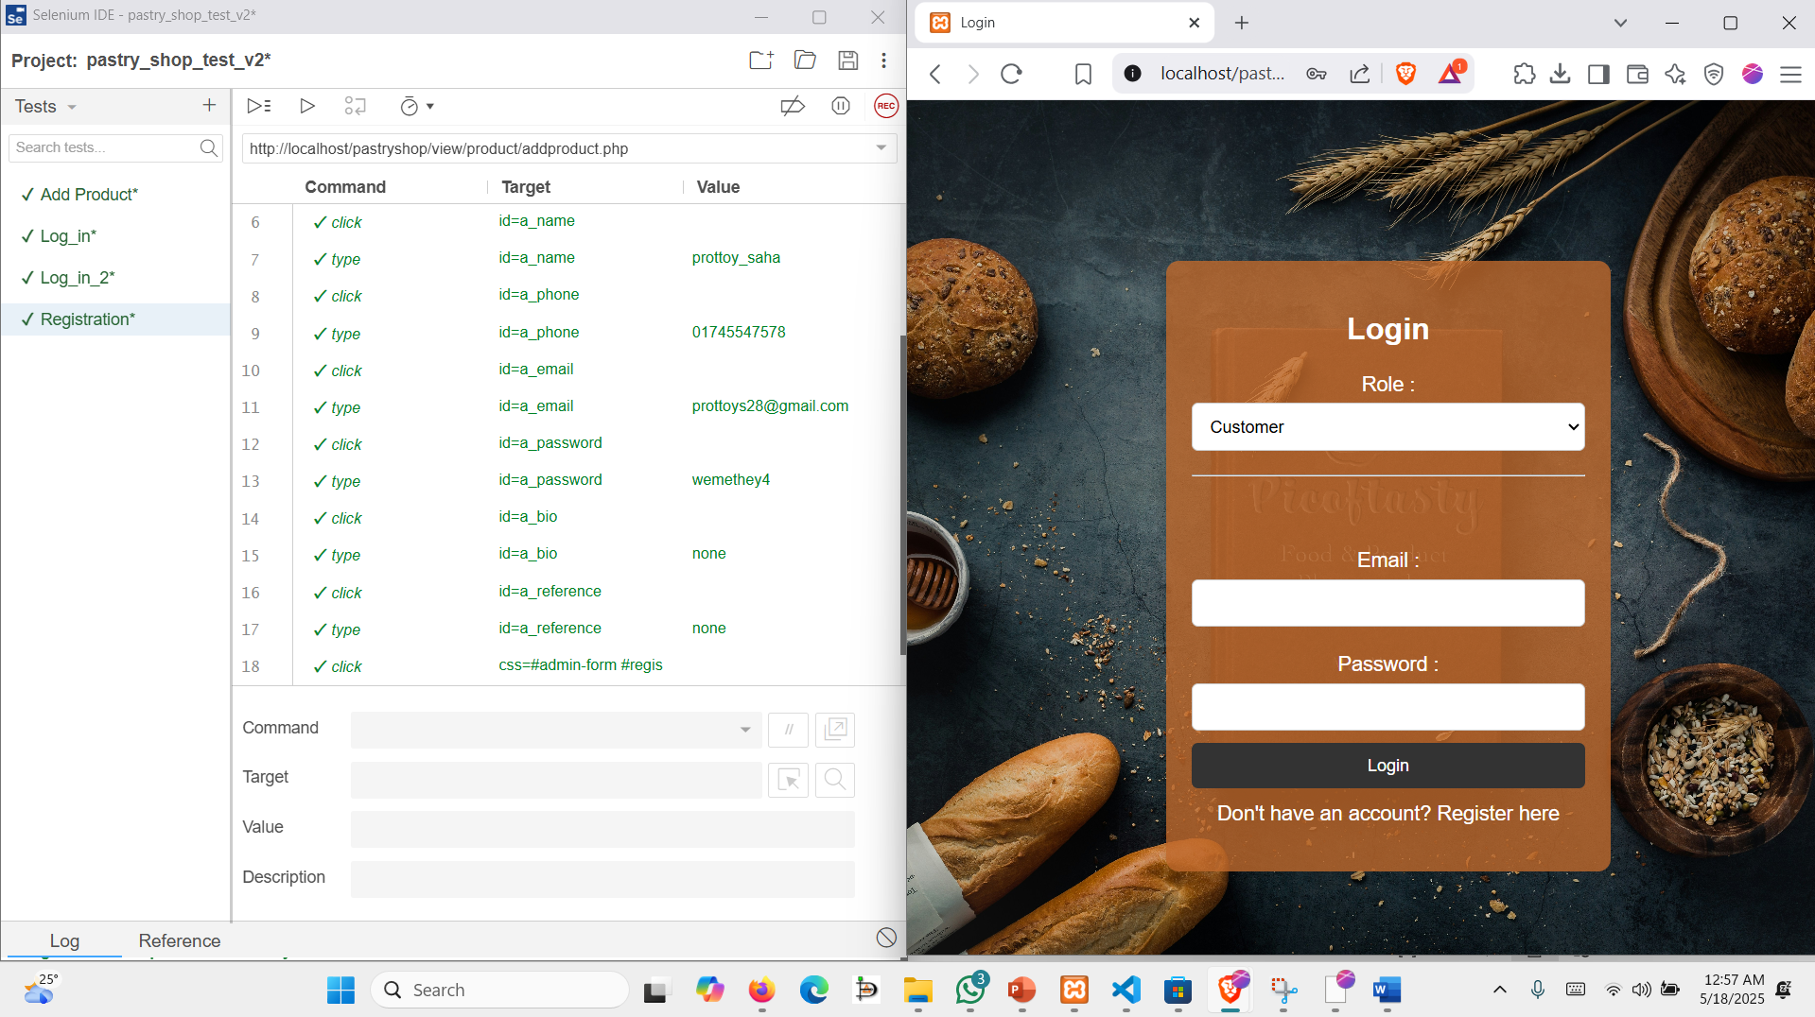

**Step 2:** After successfully recording the test, we now clicked on run current test case which shows:  
An automated test was executed using Selenium IDE to verify the registration process for an admin user on the page http://localhost/pastryshop/view/registration.php.

* The test began by opening the registration page and setting the browser window size for consistency.
* The user role was selected as Admin.
* Form fields were filled with valid input values:
  + Name: prottoy_saha
  + Phone: 01745547578
  + Email: prottoys28@gmail.com
  + Password: wemethey4
  + Bio: none
  + Reference: none
* After all required inputs were entered, the registration form (id=regis) was submitted.

The test was completed successfully, indicating that the registration flow and form validation were functioning correctly for the admin role.

**Test 4: Testing the Add new Product functionalities of the website**

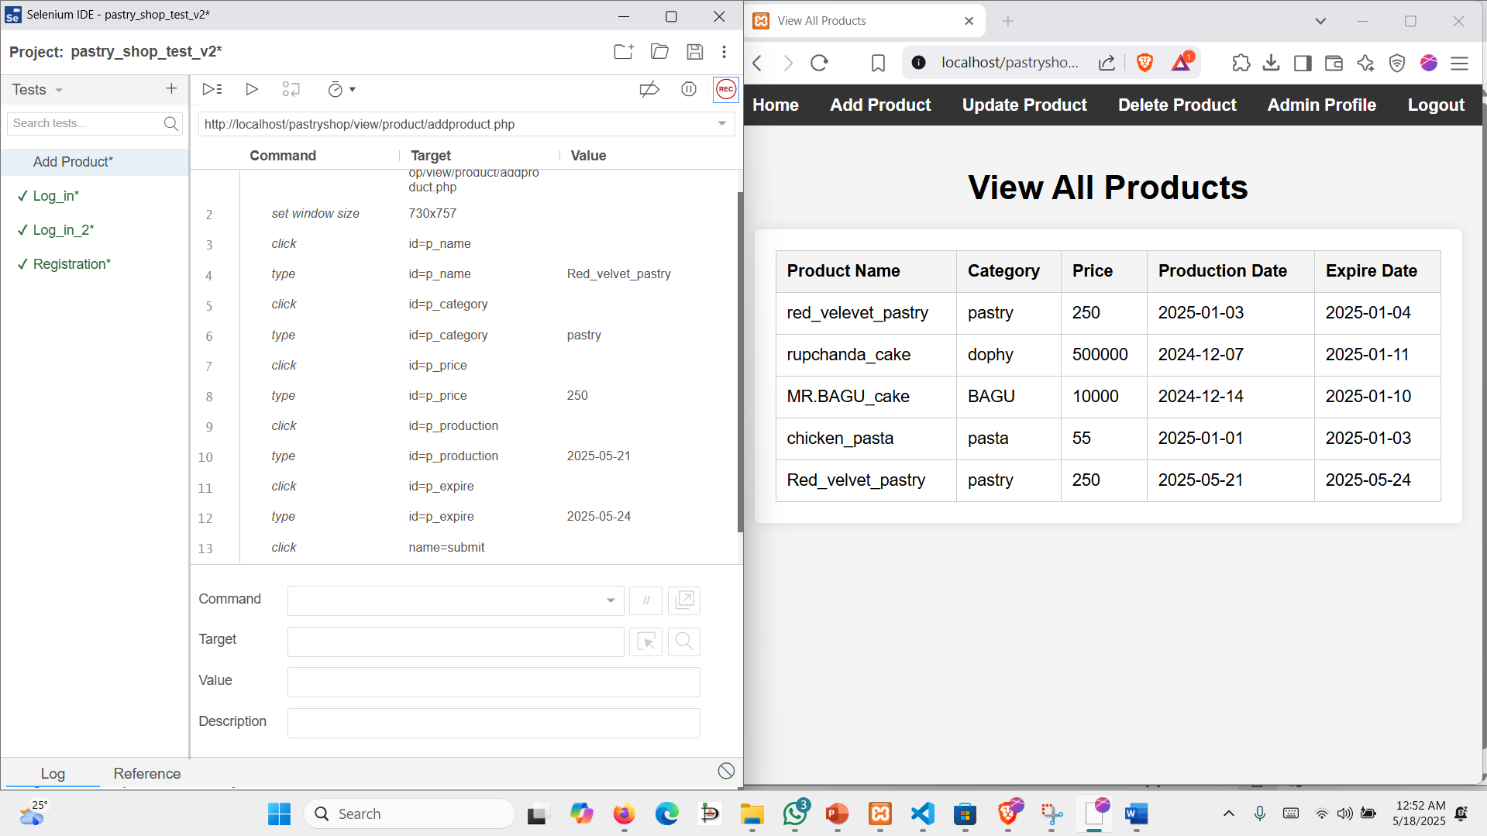

**Step1:** We added a new test case as like previous steps and named the test case as Add Product then as like previous steps for every clicking the command, target and value were recorded inside of the selenium ide.

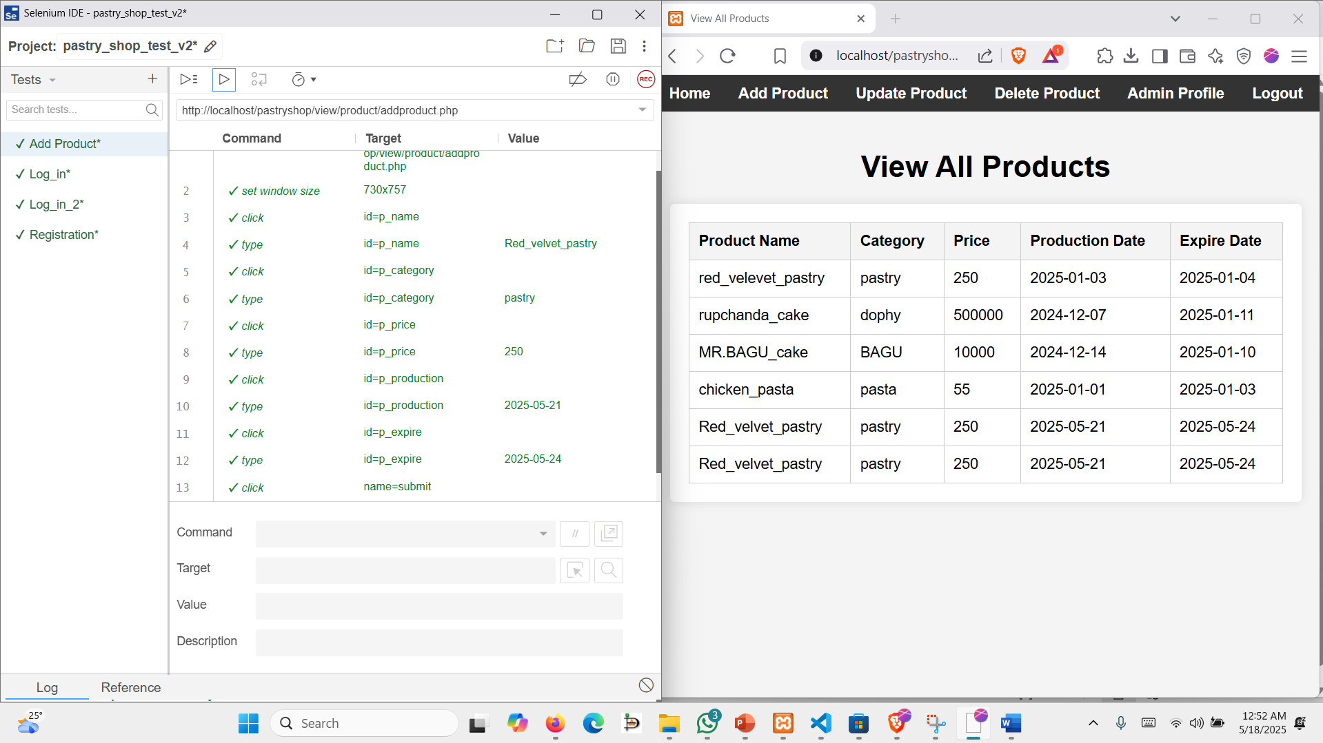

**Step 2:** After successfully recording the test, we now clicked on run current test case which shows:

The test began by opening the Add Product page and setting the browser window size.

It filled out the product form with the following details:

* Product Name: Red_velvet_pastry
* Category: pastry
* Price: 250
* Production Date: 2025-05-21
* Expiry Date: 2025-05-24

After entering all the required details, the form was submitted by clicking the submit button (name=submit). The test was completed successfully, confirming that the product addition process works as expected when valid inputs are provided. Test completed successfully – product was added without any errors.

**Test 5: Testing the Update Product functionalities of our website**

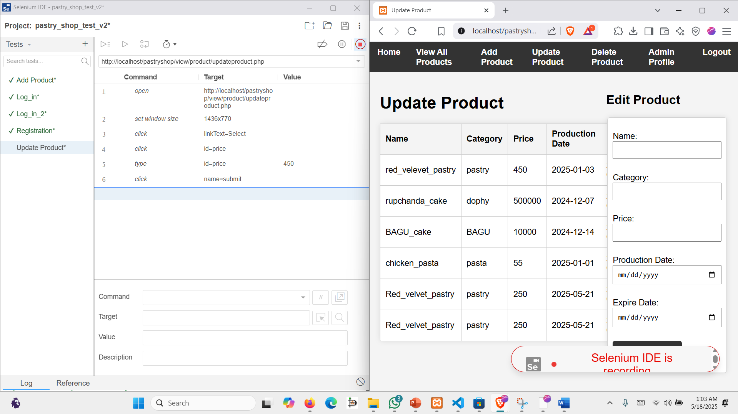

**Step1:** We added a new test case as like previous steps and named the test case as Update Product then as like previous steps for every clicking the command, target and value were recorded inside of the selenium ide.

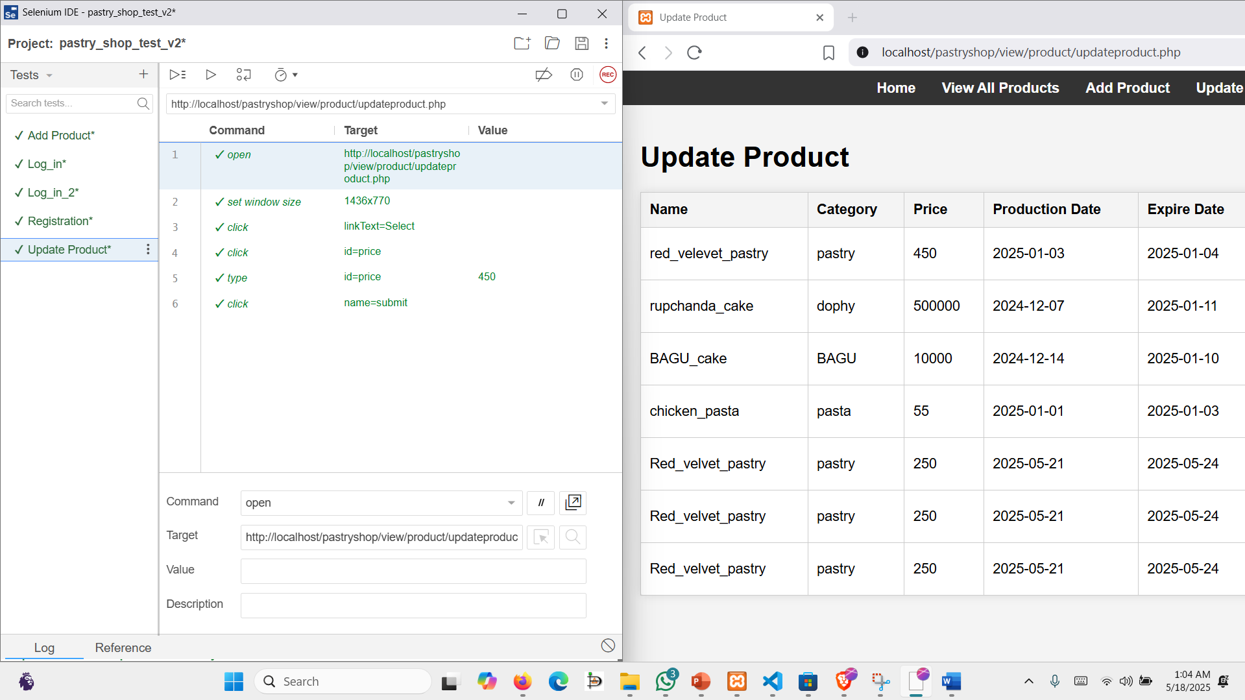

**Step 2:** After successfully recording the test we now clicked on run current test case which shows: Opened the Update Product page http://localhost/pastryshop/view/product/updateproduct.php

Set the browser window size to ensure consistent layout rendering

* Clicked on the "Select" link to choose a product for update
* Clicked on the Price input field (id=price)
* Entered new price value: 450
* Clicked the submit button (name=submit)

Test completed successfully – product was updated without errors.